
RAMAIAH
INSTITUTE OF TECHNOLOGY
USN | 1 | M | S

(Autonomous Institute, Affiliated to VTU)
(Approved by AICTE, New Delhi & Govt. of Karnataka) Accredited by NBA & NAAC with ‘A’ Grade

SUPPLEMENTARY SEMESTER EXAMINATIONS – JULY/AUGUST 2018

Course & Branch | : | B.E. : Computer Science and Engineering | Semester | : | V
Subject | : | Computer Networks | Max. Marks | : | 100
Subject Code | : | CS53 | Duration | : | 3 Hrs

Instructions to the Candidates:
- Answer one full question from each unit.

 |  | UNIT- I
1. | a) | Why is it FTP sends control information as “out-of-band”? Differentiate between out-of-band and in-band protocol. | CO1 | (05)
 | b) | Determine the file distribution time for the client-server architecture and P2P architecture and discuss the observations made to obtain the minimum distribution time. | CO1 | (10)
 | c) | Illustrate how records are inserted into the DNS database. | CO1 | (05)
2. | a) | Discuss the problems involved in circular DHT and explain how this problem can be solved with an example. | CO1 | (08)
 | b) | Write the DNS message format and explain all fields. | CO1 | (06)
 | c) | What is peer churn? Explain with an example. | CO1 | (06)
 |  | UNIT- II
3. | a) | Explain TCP segment structure with a neat block diagram. | CO2 | (08)
 | b) | Draw an FSM that describes TCP congestion control. Also explain TCP’s behavior in slow star. | CO2 | (12)
4. | a) | Illustrate with neat figure connection oriented multiplexing and demultiplexing. | CO2 | (06)
 | b) | Explain with a neat diagram the UDP segment structure. Discuss UDP checksum with an example. | CO2 | (06)
 | c) | Illustrate with neat figures the sequence of TCP states visited by the TCP client and TCP server. | CO2 | (08)
 |  | UNIT- III
5. | a) | Define fragmentation. Consider sending a 2400-byte datagram into a link that has MTU of 700 bytes. Suppose the original datagram is stamped with the identification number 422. How many fragments are generated? What are the values in the various fields in the IP datagram(s) generated related to fragmentation? | CO3 | (08)
 | b) | Discuss briefly RIP distance vector routing with suitable formulas and updating of routing table in RIP using split-horizon and poisoned-reverse rule. | CO3 | (08)
 | c) | Write an algorithm for OSPF routing. | CO3 | (04)
6. | a) | For the network shown in the following Figure; (i) Find the least-cost path between the two servers, using the Bellman-Ford algorithm. (ii) Show an iteration graph as the least-cost path is developed.  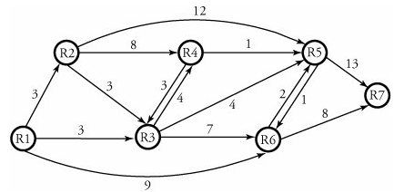 | CO3 | (08)
 | b) | An organization is granted the block 130.56.0.0/16. The administrator wants to create 1024 subnets.  - Find the number of addresses in each subnet.  - Find the subnet prefix.  - Find the first and the last address in the first subnet  - Find the first and the last address in the last subnet. | CO3 | (06)
 | c) | Compare NAT and DHCP. Explain how both can solve the problem of a shortage of addresses in an organization, but by using different strategies. | CO3 | (06)
 |  | UNIT- IV
7. | a) | Consider the following figure for usage of MOSPF to multicast from router R1 to seven servers located in two different multicast groups spread over three LANs. Assume that we want to implement MOSPF from a server in LAN 1 to a multicast group of five members, three group members in LAN 3 and the two others in LAN 4. Also assume that the cost of each link is indicated by the sum of two ending routers' subscripts. For example, the cost of link R3 to R8 is 11. If a router ends a LAN, the cost of its associated link is assumed to be 1. (i) Show the cost of all links on the network. (ii) Form the least-cost tree for this multicast action, and find the root of copying routers.  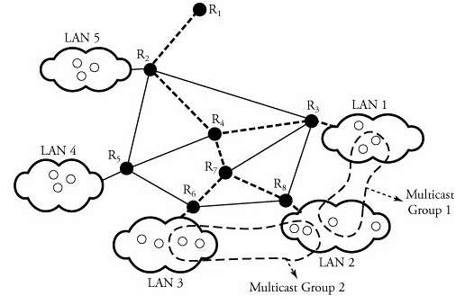 | CO4 | (10)
 | b) | Describe the purpose of the HLR and VLR in GSM networks? What elements of mobile IP are similar to the HLR and VLR? | CO4 | (06)
 | c) | Explain the similarities and difference with respect to infrastructure and ad-hoc networks in detail. | CO4 | (04)
8. | a) | Suppose there are two ISPs providing WiFi access in a particular café, with each ISP operating its own AP and having its own IP address block.  i. Further suppose that by accident, each ISP has configured its AP to operate over channel 11. Will the 802.11 protocol completely break  down in this situation? Discuss what happens when two stations, each associated with a different ISP, attempt to transmit at the same time.  ii. Now suppose that one AP operates over channel 1 and the other over channel 11. How do your answers change? | CO4 | (06)
 | b) | What is advantage of using sparse mode shared tree over dense mode source based tree. | CO4 | (06)
 | c) | In mobile IP, what effect will mobility have on end-to-end delays of datagram between the source and destination? | CO4 | (08)
 |  | UNIT- V
9. | a) | Write an algorithm for leaky bucket traffic shaping and explain with an example. | CO5 | (08)
 | b) | Compare preemptive and nonpreemtive priority queues. With respect to packet scheduling. | CO5 | (06)
 | c) | List and explain the components of H.323 protocol. | CO5 | (06)
10. | a) | Discuss real-time transport protocol packet header with neat block diagram. | CO5 | (08)
 | b) | Illustrate weighted fair queuing scheduler with a neat figure. | CO5 | (08)
 | c) | Distinguish between RTP and RTCP packets. | CO5 | (04)

****************

